Legan Livestock & Grain Internship Program

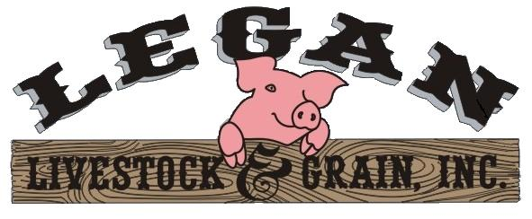

Thank you for your interest in Legan Livestock & Grain’s Internship Program! We understand the importance of the internship experience to students for job experience and future employment. We also value the ideas and enthusiasm of new interns. We have been fortunate to employ interns from various schools in the past several years. College Interns have come to us from Purdue University, Ivy Tech Community College, Lakeland Community College (IL), and the University of Findley (OH). We have also employed high school interns through Area 30 Technical School.

About Legan Livestock and Grain:
Legan Livestock & Grain is located in central Indiana approximately 40 miles west of Indianapolis and 30 miles east of Terre Haute. We are a 3,000 sow breed to wean family farm producing 80,000 weaned pigs annually. One third of the weaned pigs are sold to customers (farmers) in Indiana & Illinois and the rest are co-owned with two other partners in Indiana. We crop farm approximately 1,000 acres of corn and soybeans as well.
Below is a comment from a previous intern.
“While pursuing a career as a production animal veterinarian, this internship gave me an inside view of one of America’s primary production animals – swine. I have gained an understanding of the pork industry from the producers' standpoint. Through this internship, I now have a clearer understanding of a producer’s need to carefully consider and weigh the pros and cons of treatment options”. ~ Joni (summer 15’)
Internship Program: We will try to adapt the internship to the student’s interest.
- Experience in swine production areas of farrowing and breeding and gestation.
- Farrowing monitoring - Animal Husbandry
- Sow movement - Bio-security
- Artificial Insemination - Gilt Development
- Feeding
- Experience in entry and analysis of sow & market hog production records.
- On Farm Research – Past interns have conducted research and earned university credit.

How to apply: Fill out our application at www.leganlivestock.com and return with references.
Housing: Housing on site is available with terms to be agreed upon by the owners and intern.
Compensation: We think it is important for an intern to be paid for their work. Compensation would be agreed upon by the owners and intern.
Questions: Contact Phyllis Legan at plegan@leganlivestock.com or 765-246-6634
For more information please visit our web page at www.leganlivestock.com
Please “like” us on our Facebook page, Legan Livestock and Grain.

