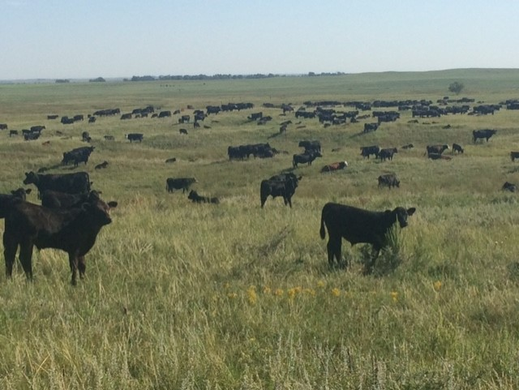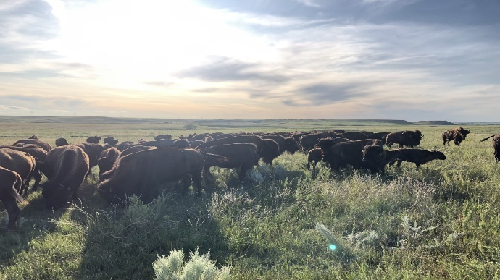
Black Leg Ranch
Summer 2020 Internship

Black Leg Ranch is again offering an internship opportunity for the upcoming summer. The program will run from May 15th- August 15th (dependent on College schedule). Students will have the opportunity to earn college credits upon successful completion of the internship.
The ranch is a family owned operation consisting of 17,000 deeded acres. The headquarters are located 7 miles SE of McKenzie, ND, or 25 miles SE of Bismarck. We are a commercial cow/calf operation with 700 cows and graze an additional 2,000 head of cows in the summer. We also have a 250 head herd of bison on the ranch. In addition, we operate several ag related ventures on the ranch. Rolling Plains Adventures, a full-service hunting/outfitting operation, Black Leg Events, an agri-tourism operation, Black Leg Brewery, and Black Leg Ranch Meats, using our own sourced cattle and bison.
We utilize Holistic Management to operate the ranch and focus on regenerating our rangelands, cropland, and wildlife. We use no-till and cover crops to winter graze allowing us to cut feed costs and build soil health. We calve our cows in May and June and intensively manage our grazing system utilizing planned rotational grazing.
Black Leg Ranch has won many awards including the Aldo Leopold Conservation Award and the NCBA National Environmental Stewardship Award.
Job Duties:
-Assisting with calving
-Building/fixing fence
-Moving/checking cattle
-Assisting with planting
-Assisting with haying
-General maintenance/mechanics
-Day to day ranch requirements
-Intern will also be able to learn principles of Holistic Management, Intensive Grazing, Utilizing Cover Crops to build soil health and to cut winter feed costs, and practices to become profitable in a ranching business.
-The intern will be able to observe diverse ventures, Rolling Plains Adventures [a full-service hunting outfitting business], a sawmill, an on-site brewery, and an Agri-Tourism operation hosting weddings, corporate events, soil health tours, and many events promoting and spreading a positive image of Agriculture.
Interns will be provided with on ranch housing, pay will be given as well as a potential bonus upon completion of successful internship. Expect to work the same hours as we do from Monday-Saturday. Sundays will be given off, unless prior arrangements have been made.
Deadline for Summer Internship Application: March 10 (Interviews will be conducted Mid-March)
For more information on the ranch go to YouTube and search Black Leg Ranch. There are several videos highlighting what the ranch is all about, two of which are linked below.
https://youtu.be/iozmnLon1ic
https://youtu.be/kY9Lre_yFFY
“My summer working for the Black Leg Ranch was not only very beneficial, but my experience exceeded all of my expectations by more than I ever could have hoped for. I appreciate the fact that I was given the opportunity to do a variety of different jobs; everything from haying and fencing to branding and checking cows. I left knowing I received a well-rounded experience. The Doans made me feel like part of the family and the friendships I made there will not soon be forgotten.”.
- Alex Ames, University of Wyoming (2018 Black Leg Ranch summer intern)

“My summer internship at Black Leg Ranch was a pleasurable and beneficial learning experience. I acquired so many new skills that will help me along my career path. Completing this internship has furthered my independence, professional communication, and networking abilities. The entrepreneurship of the Doan family has developed a truly amazing cattle ranch and is continuing to capitalize on up and coming niche markets. I am honored to have partaken in the Ranch’s history and I would highly recommend this internship”.
- Alexander Golin, Michigan State University (2019 Black Leg Ranch summer intern)
Black Leg Ranch Internship Application
Application Deadline- March 10, 2020
Name:
Phone #:
Email address:
Mailing Address:
Date of Birth:
Do you have a valid driver’s license?
Major:
Minor:
GPA:
Year in School:
Advisor Name:
Advisor E-mail:

Please answer each of the following questions using a separate sheet if necessary-
- Describe your agricultural background
- Why do you want to intern at Black Leg Ranch?
- Have you ever done an internship before?
- What are your main skills/areas of expertise?
- Have you ever operated equipment such as a tractor, swather, baler, planter, etc.?
- What are your extra-curricular activities?
- List any awards/accomplishments/achievements
- What would set you apart from other intern applicants?
- Are you willing to do manual labor that may require you to go beyond your comfort zone? (please explain)
- What is your experience level with barbed wire and electric fence?
- What are your long-term goals?
- What is your experience with cattle and animals?

Lastly, please submit a 500 word maximum essay on the following:
How would you benefit from interning at Black Leg Ranch, and how would Black Leg Ranch benefit from having you as an intern?

*Please check other Internships/Job opportunities you may be interested in at Black Leg Ranch (not required to fill out if not necessary).
_____6 Month Ranch Internship (June-Nov)
_____Fall Internship (Aug-Nov)
_____Full-Time Ranch Employment (year-round)
_____Hunting/Guiding (Oct-Nov)
_____Agri-Tourism Summer Internship (May-Aug)

Please complete the application in its entirety and email or mail back to Black Leg Ranch
blackleginternships@outlook.com
24401 62nd Ave. SE McKenzie, ND 58572
(701) 220-8443

Good Luck and Thank You

