Are you interested in the field of Laboratory Animal Health?
If so, University Laboratory Animal Resources (ULAR) is offering a shadowing opportunity for current OSU undergraduate students.
About our program:
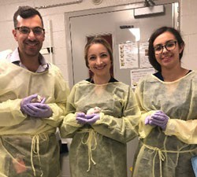
The laboratory animal facilities at OSU encompass 14 separate buildings with >200,000 square feet of animal space. The range of species is extremely diverse, including mice, rats, farm animals, dogs, cats, non-human primates and various exotics. The research programs cover areas such as cardiovascular disease, cancer, immunology, genetics, virology and neuropsychology. Students are provided with a unique exposure to a diverse and vigorous research community.
Faculty veterinarians and special expertise available:
- Six ACLAM Board Certified Veterinarians
- One Agricultural Clinical Practice Veterinarian
- One Research Veterinarian
- Three Laboratory Animal Veterinary Residents
What to expect:
- Spending the day in multiple laboratory animal facilities
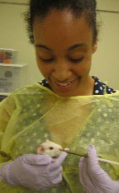
- Learn about and observe day-to-day operations of a laboratory animal facility
- Have one-on-one discussions with our clinical veterinarians and technicians
- Brown bag lunch with clinical and resident veterinarians
- Observe large animal experimental surgery
- Attend rodent/small animal medicine rounds and observe clinical cases

Interested students:
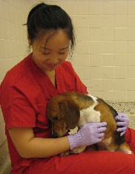
The fall shadowing opportunity is tentatively scheduled for Thursday October 13th.
If you are interested in learning more about this opportunity, please email to the contact information below.
Submit emails directly to:
Dr. Stacey Meeker, DVM, PhD, DACLAM
Director, Lab Animal Training Program
Lamresidency@osu.edu

