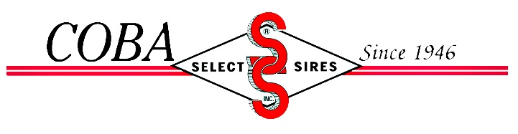
Communications/Marketing Intern Position
Goal:
To provide a wide range of experiences within the dairy industry and how the COBA/Select Sires cooperative supports and functions within the industry. To expose students to all facets of the business including communications, marketing, technician work, cattle evaluation and sales. To provide assistance to the communications and marketing staff to support all field activities.

Duties:
- Organize and fulfill the weekly route mailings for all sales personnel.
- Help design print advertisements and route inserts to support the weekly route mailings.
- Develop promotional posters for staff distribution.
- Newsletter support including photography, interviewing, writing and story ideas.
- Ride with and support activities of District Sales Managers, Select Reproductive Specialists, Select Mating Specialists, and Reproductive Services Client Managers.
- Help in development and maintenance of website.
- Assist with mailing/shipping information to all internal and external customers.
- Operate all office machines, copier, folder/inserter, postage machine etc.
- Assist with semen packing and invoicing as requested.
- Provide phone relief to the Receptionist/Marketing Assistant as needed.
- Promote and represent COBA at industry functions including Ohio State Fair, trade shows, farm tours, industry meetings.
- Any other duties as requested by the Administrative Director for the needs of the cooperative.
Hours:
Normal business hours from 8:00 am to 4:45 pm, schedule to be determined and set in conjunction with the Administrative Director. Travel within COBA’s northern service area to include some overnight will be expected.

Compensation:
- Hourly wage plus expenses of corporate travel and responsibilities.
Reports to:
Administrative Director

Successful candidate should have knowledge of dairy/beef industries, proficient in Microsoft Office and Adobe Creative Suite with strong written and oral communication skills. Internship is based at the Columbus, Ohio office. Please send application, resume and cover letter to coba@cobaselect.com.

